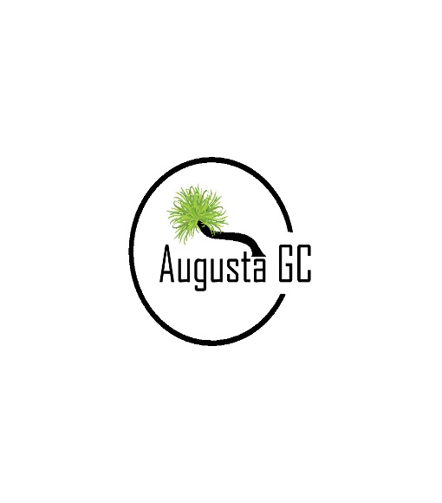

HIRE OF MOTORISED CART

Name

Address

Phone (Mobile) Phone (Home)

Driver’s Licence No

Car Registration

PLEASE NOTE:
KNOWING YOUR RESPONSIBILITIES WHEN HIRING A MOTORISED CART
- Strictly no alcohol permitted when in charge of a motorised cart.

- Motorised carts should follow directional signage, and not come within 10 metres of a green or surround.

- Motorised carts are not to be driven off maintained grass areas or designated pathways.

GOLFERS ARE RESPONSIBLE FOR DAMAGES. The Augusta Golf Club will not accept liability for damage to the carts.
REPLACEMENT OF CART $8000.00

